Software Requirements Specification (SRS)

EgyCinema System

1. Introduction

1.1 Purpose
The purpose of this document is to describe the functional and non-functional requirements of the EgyCinema System. The system is designed to provide an online cinema management and ticket booking platform that allows users to browse movies, manage cinemas and halls, book tickets, and process payments.

1.2 Scope
EgyCinema is a microservices-based cinema management system developed using Spring Boot, SQL Server, Docker, and AWS S3.
The system provides:
- User authentication and authorization
- Cinema and hall management
- Movie management
- Showtime management
- Ticket booking
- Payment processing
- Poster uploading using AWS S3

1.3 Technologies Used
Technology | Purpose
Spring Boot | Backend Framework
SQL Server | Database
Docker | Containerization
AWS S3 | Image Storage
JWT | Authentication
HTML/CSS/JS | Frontend
Maven | Dependency Management
AOP | Logging

2. System Architecture
The system follows:
- Microservices Architecture
- MVC Pattern
- Repository Pattern
- Service Layer Pattern
- Dependency Injection
Services:
- Cinema Service
- Showtime Service
- Booking Service
- Payment Service
- Authentication Service

3. Functional Requirements

3.1 Authentication

Features
- User Registration
- User Login
- JWT Authentication
- Role-based Authorization

Actors
- Guest
- Customer
- Admin

3.2 Cinema Management

Features
- Create Cinema
- Update Cinema
- Delete Cinema
- Add Hall to Cinema
- View Cinemas

Actors
- Admin
- Customer

3.3 Movie Management

Features
- Create Movie
- Upload Movie Poster
- Update Movie
- Patch Movie
- Delete Movie
- View Movies

Actors
- Admin
- Customer

3.4 Showtime Management

Features
- Create Showtime
- Update Showtime
- Delete Showtime
- View Showtimes
- Filter Showtimes by Movie
- Filter Showtimes by Cinema

Actors
- Admin
- Employee
- Customer

3.5 Booking Management

Features
- Create Booking
- View Bookings

Actors
- Customer

3.6 Payment Management

Features
- Create Payment
- View Payments

Actors
- Customer

4. Non-Functional Requirements

4.1 Security
- Password hashing using SHA-256 with salt and pepper
- JWT authentication
- Role-based authorization

4.2 Performance
- Fast response time
- Optimized database access using repositories

4.3 Scalability
- Microservices architecture allows scaling services independently

4.4 Availability
- Cloud-based image storage using AWS S3

4.5 Maintainability
- Layered architecture improves maintainability
- Clean separation between controllers, services, and repositories

5. Design Patterns

5.1 Repository Pattern
Used to separate database operations from business logic.
Examples:
- MovieRepository
- BookingRepository
- PaymentRepository

5.2 Service Layer Pattern
Used to encapsulate business logic.
Examples:
- MovieService
- PaymentService
- ShowTimeService

5.3 Dependency Injection
Spring Dependency Injection is used using:
- @Autowired
- Constructor Injection

5.4 MVC Pattern
The system follows MVC architecture:
Layer | Implementation
Model | Entities
View | Frontend
Controller | REST Controllers

5.5 AOP Pattern
Implemented using LoggingAspect for logging operations.

6. Class Diagram
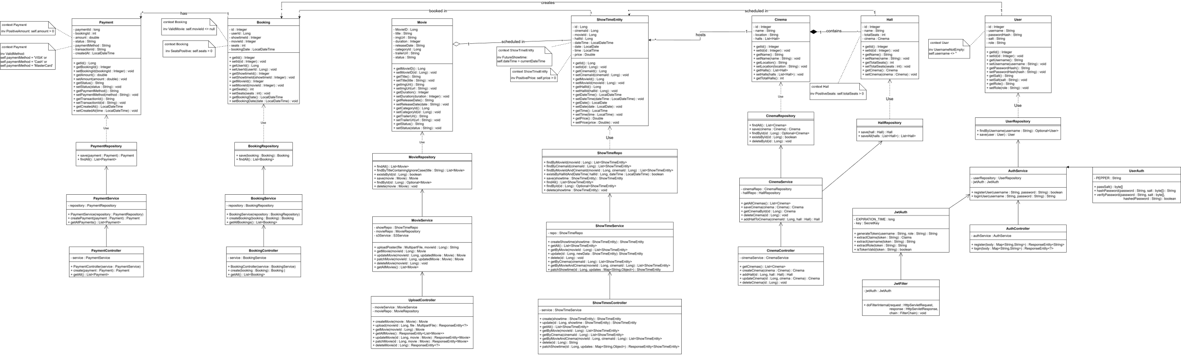

7. Use Case Diagram

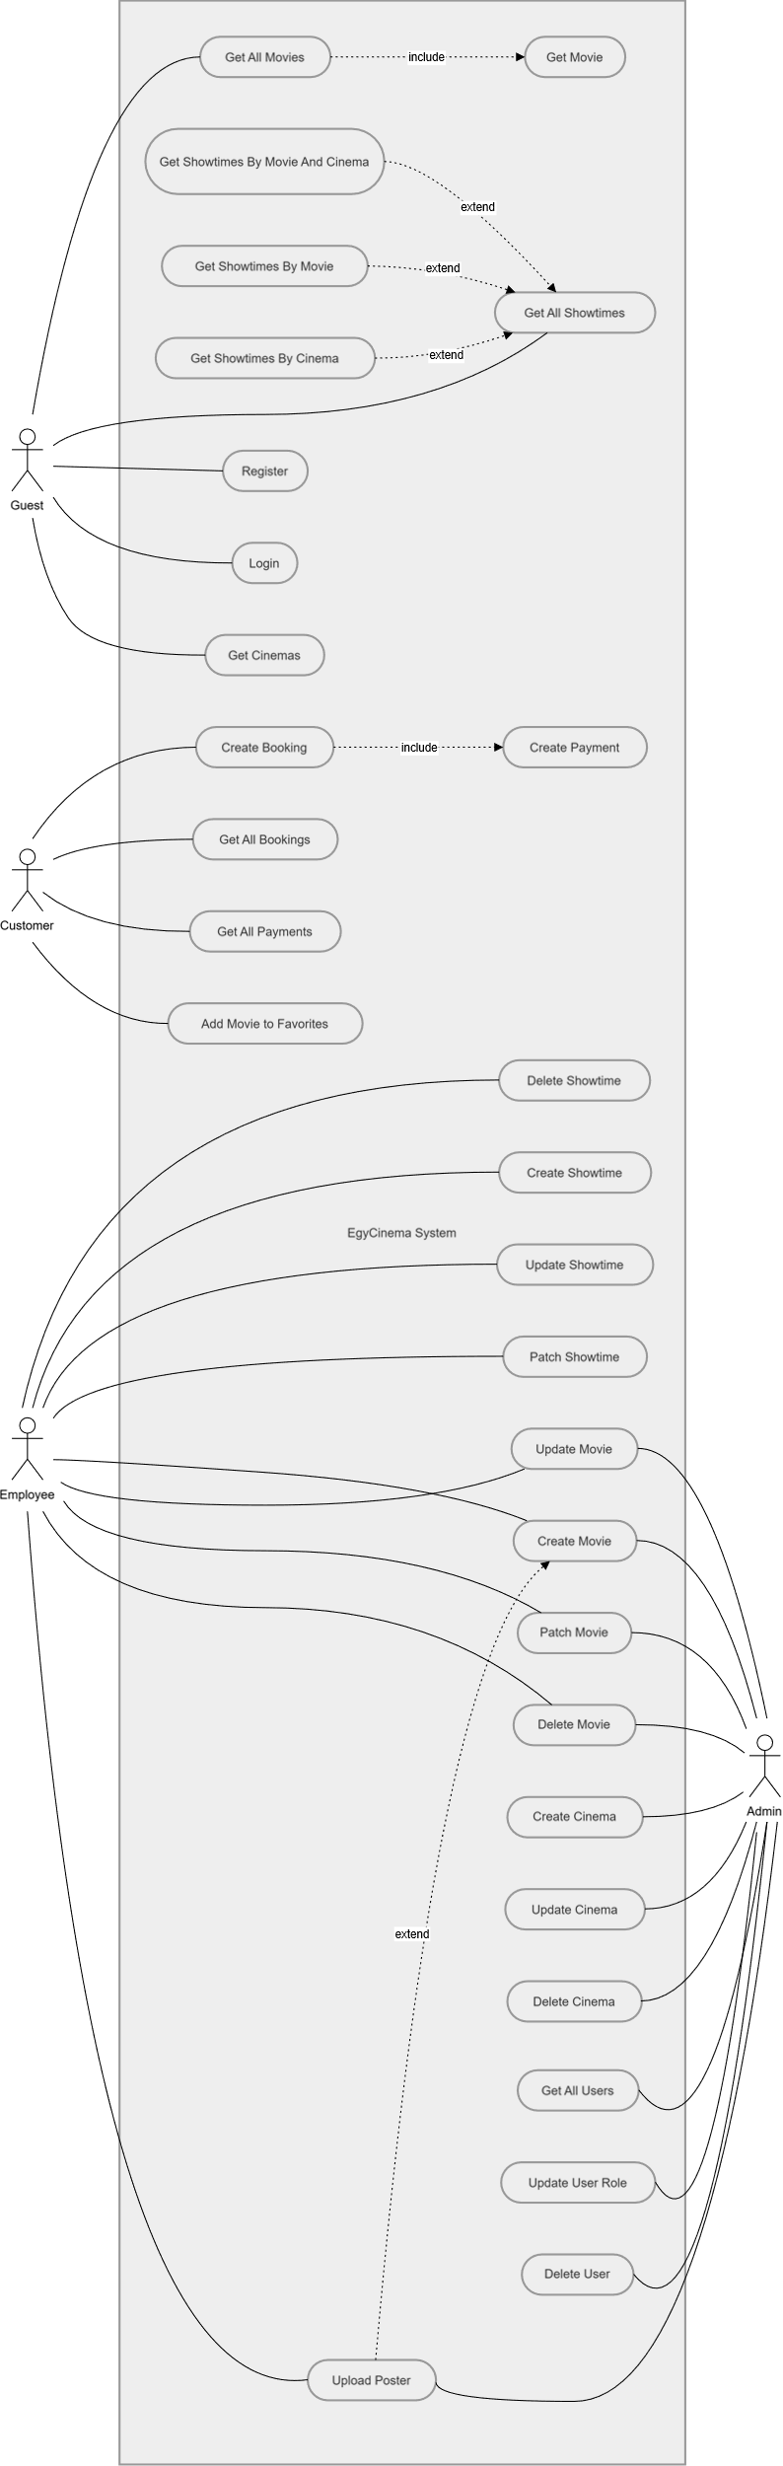

8. Activity Diagram
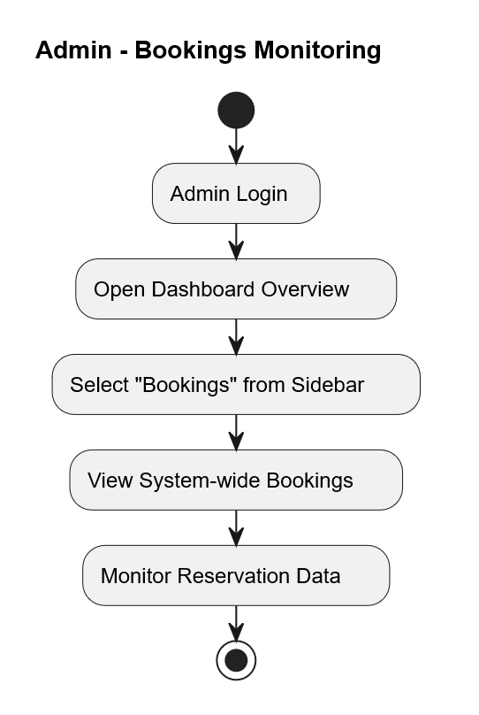

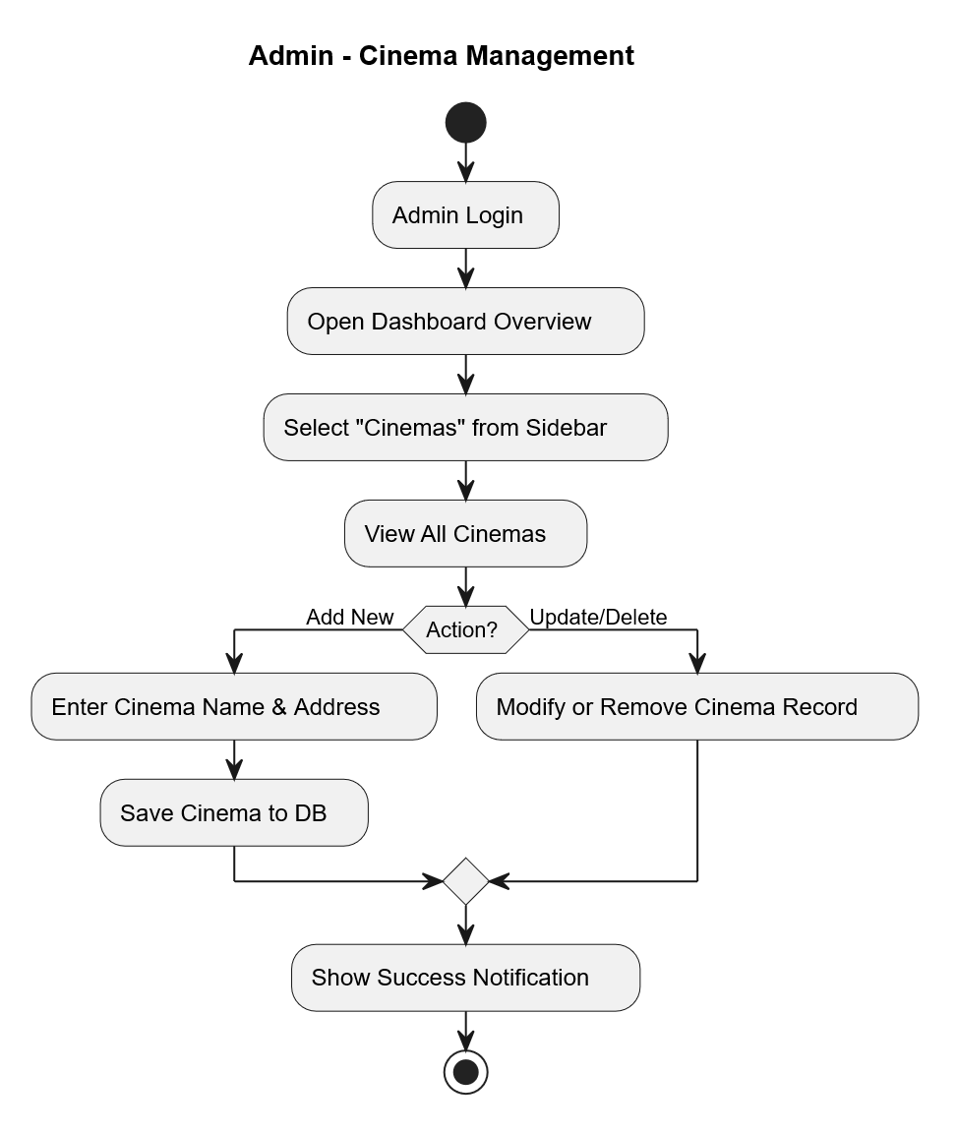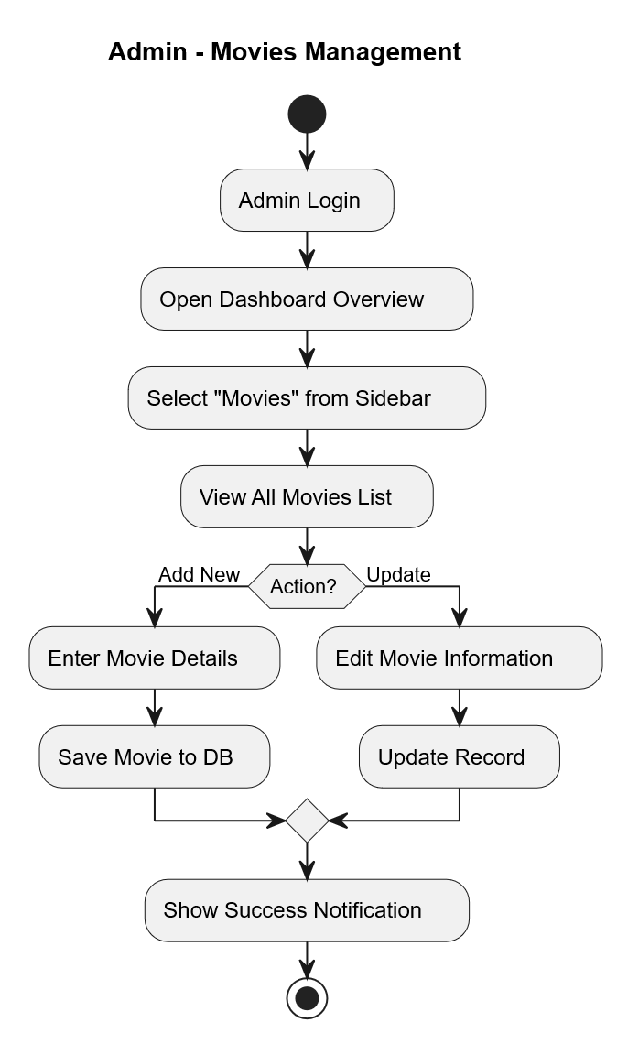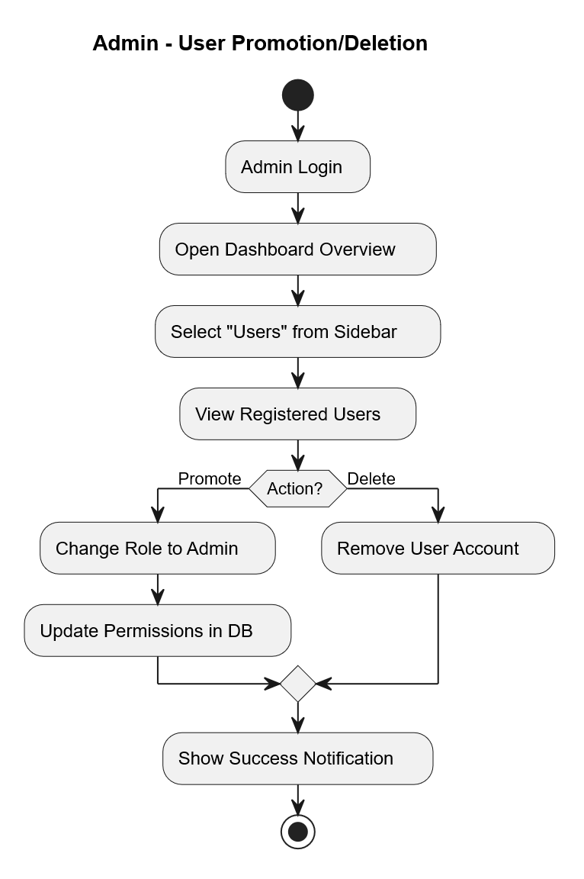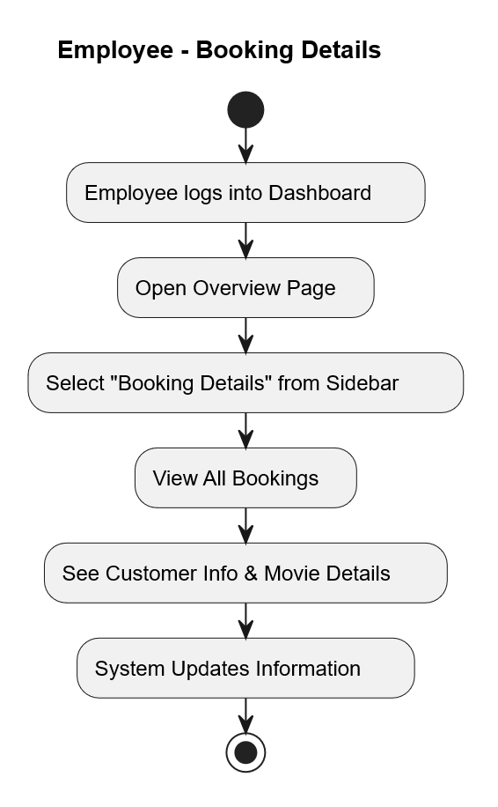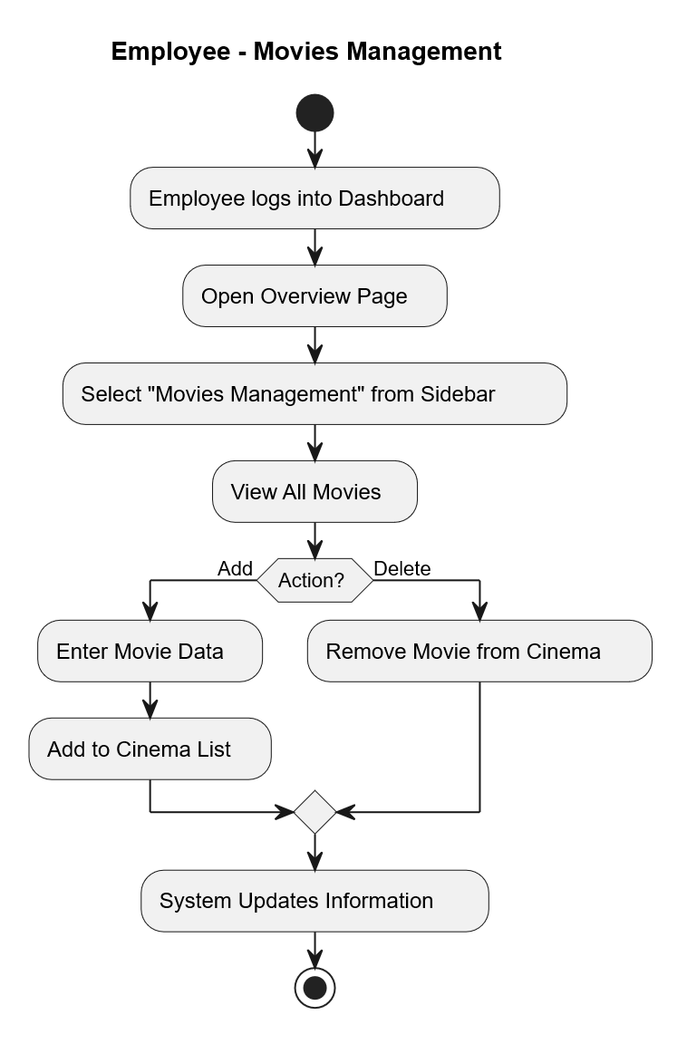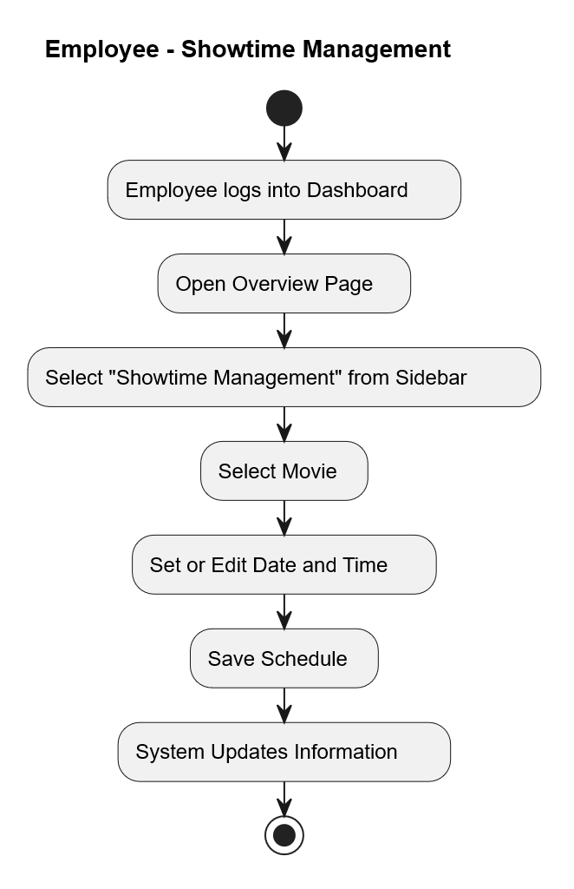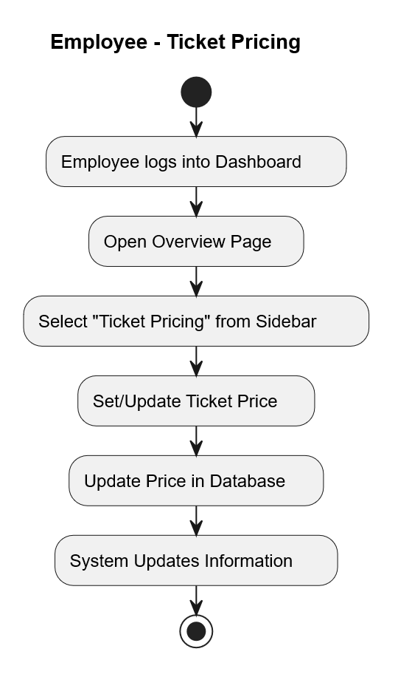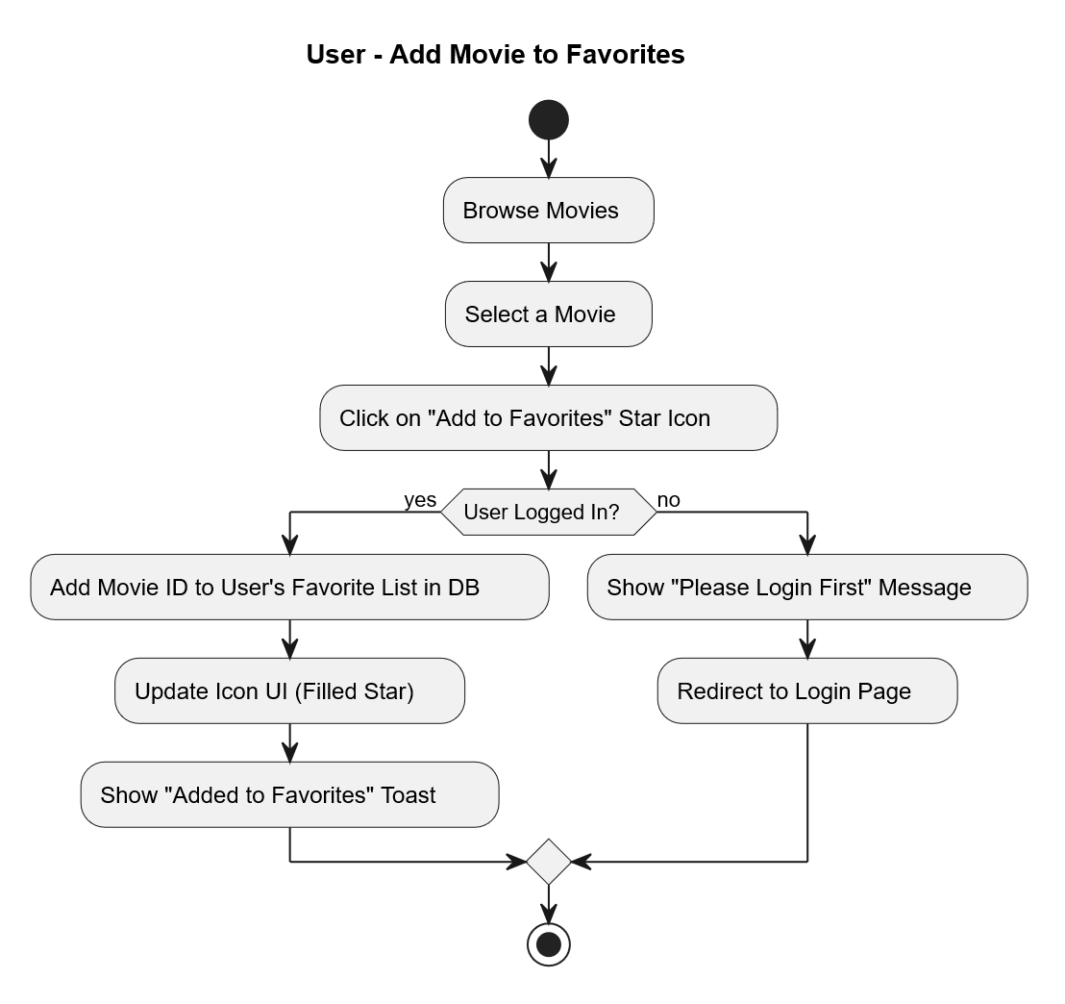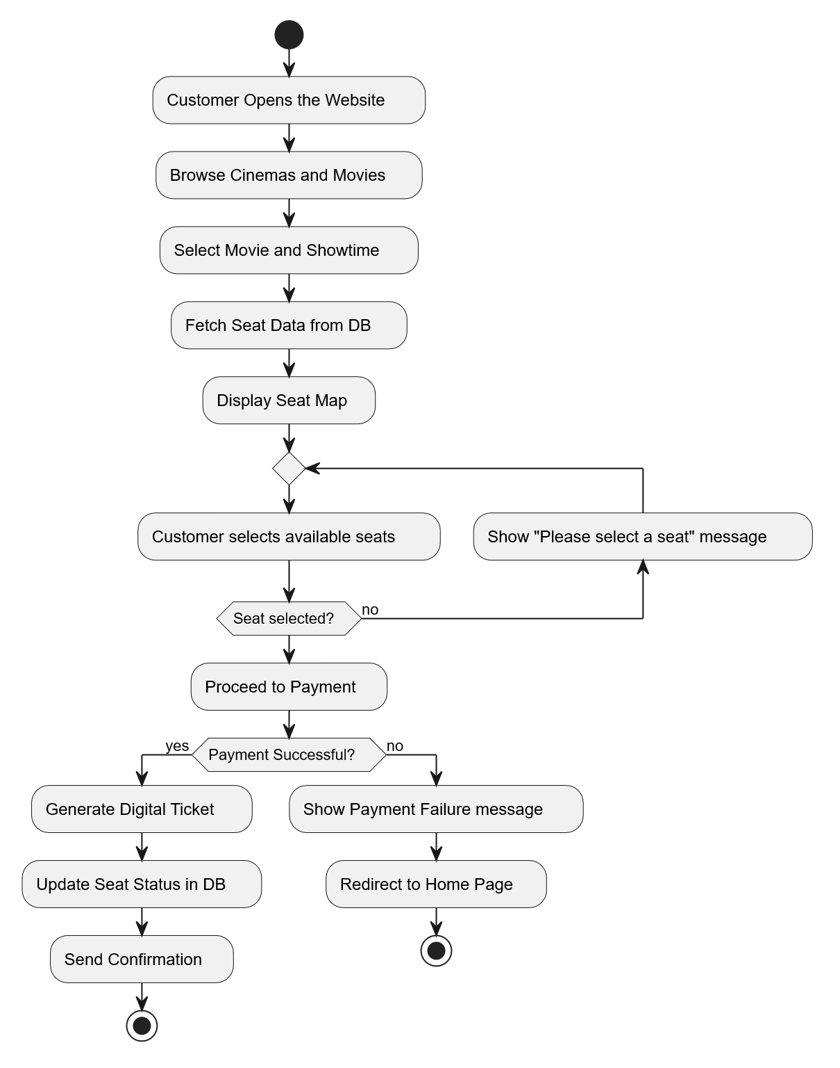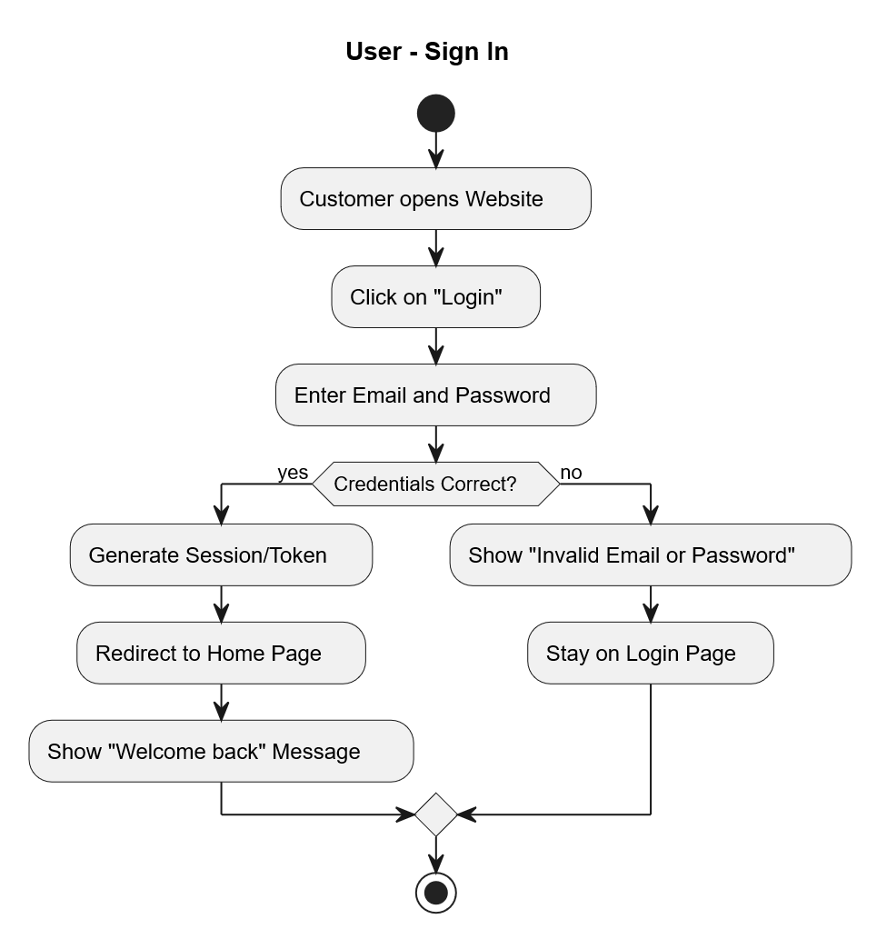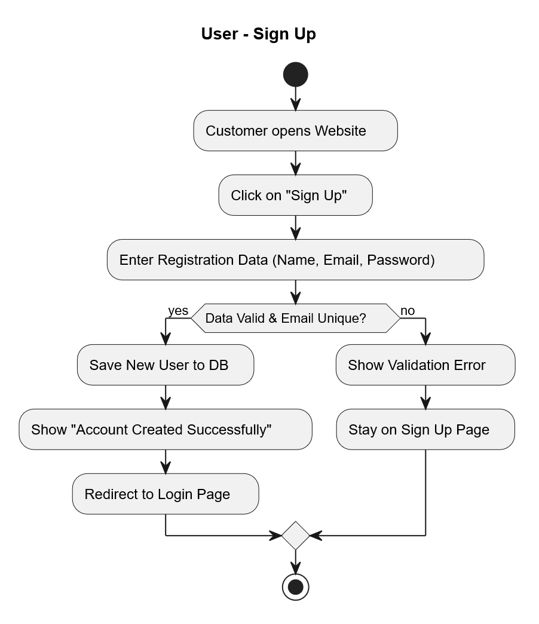

9. Sequence Diagrams
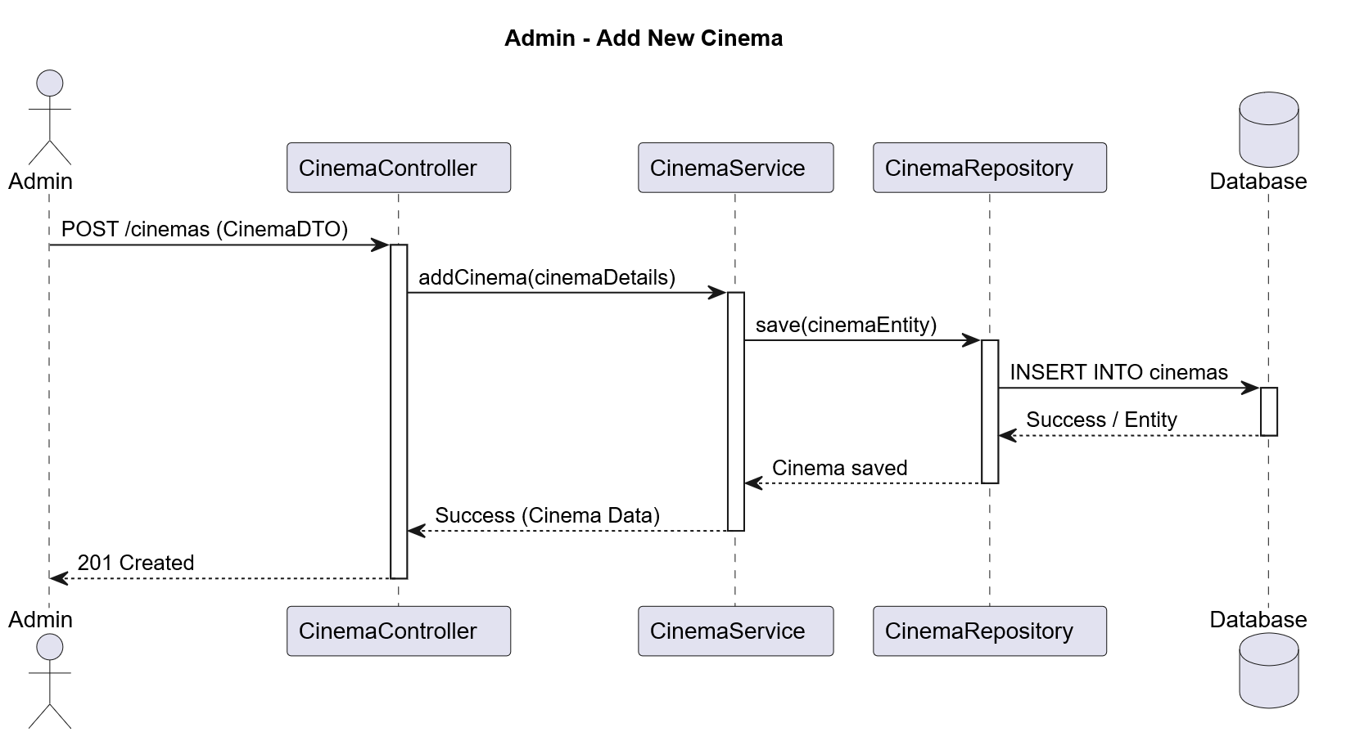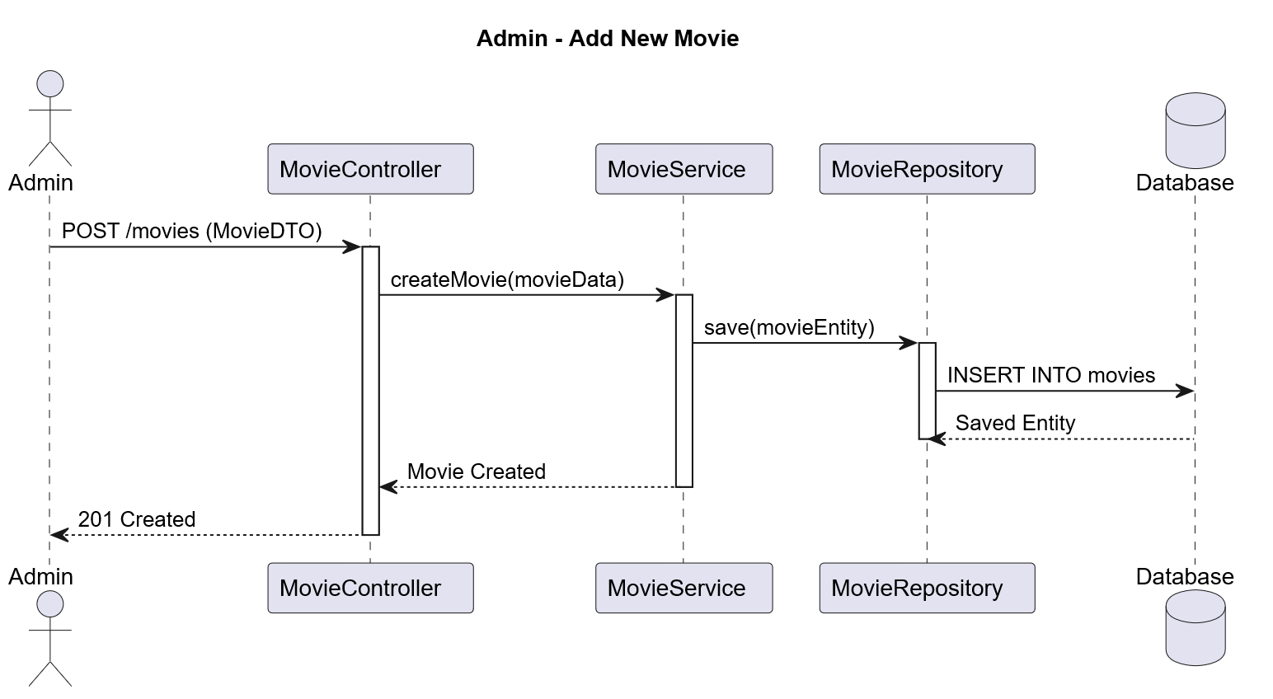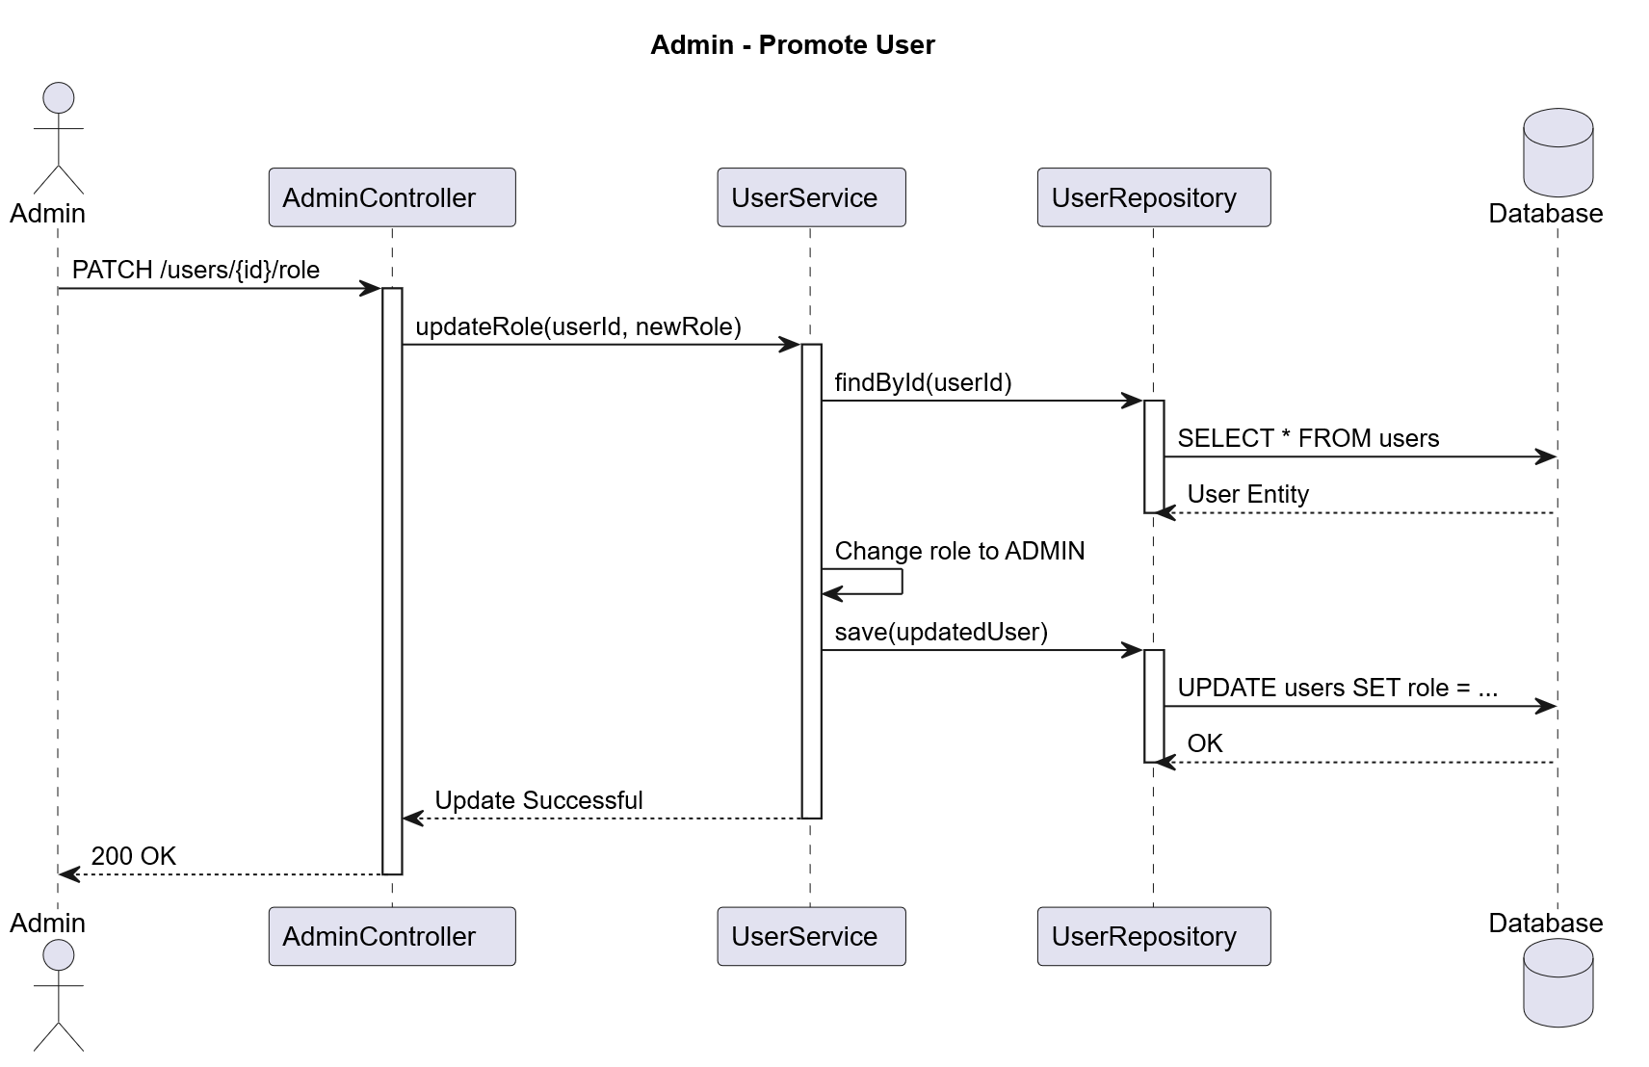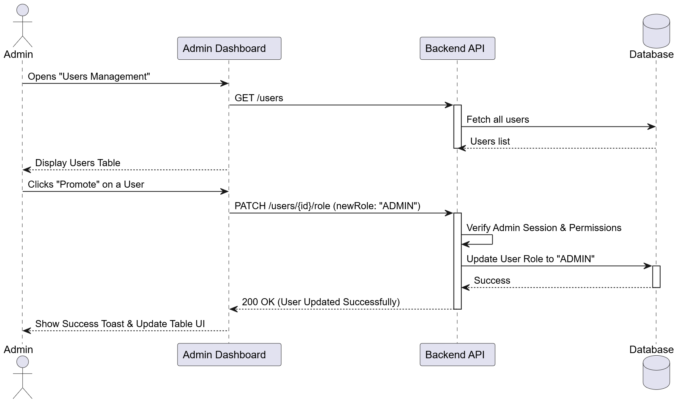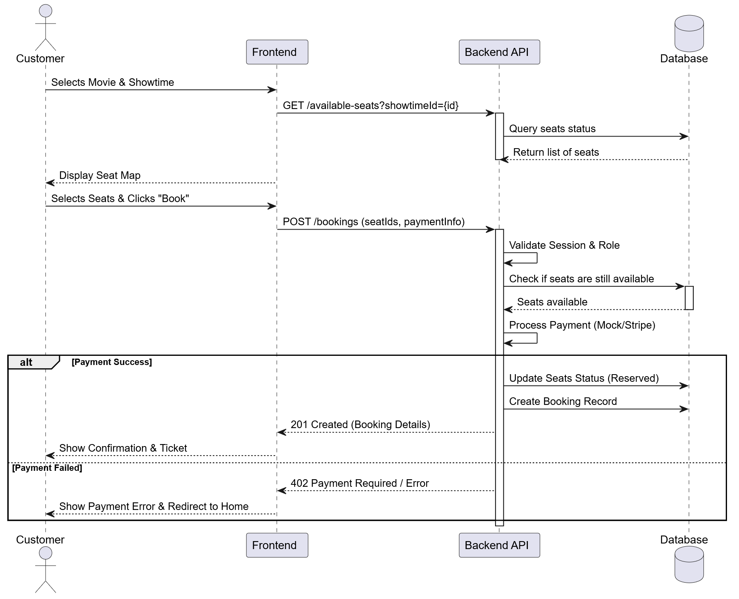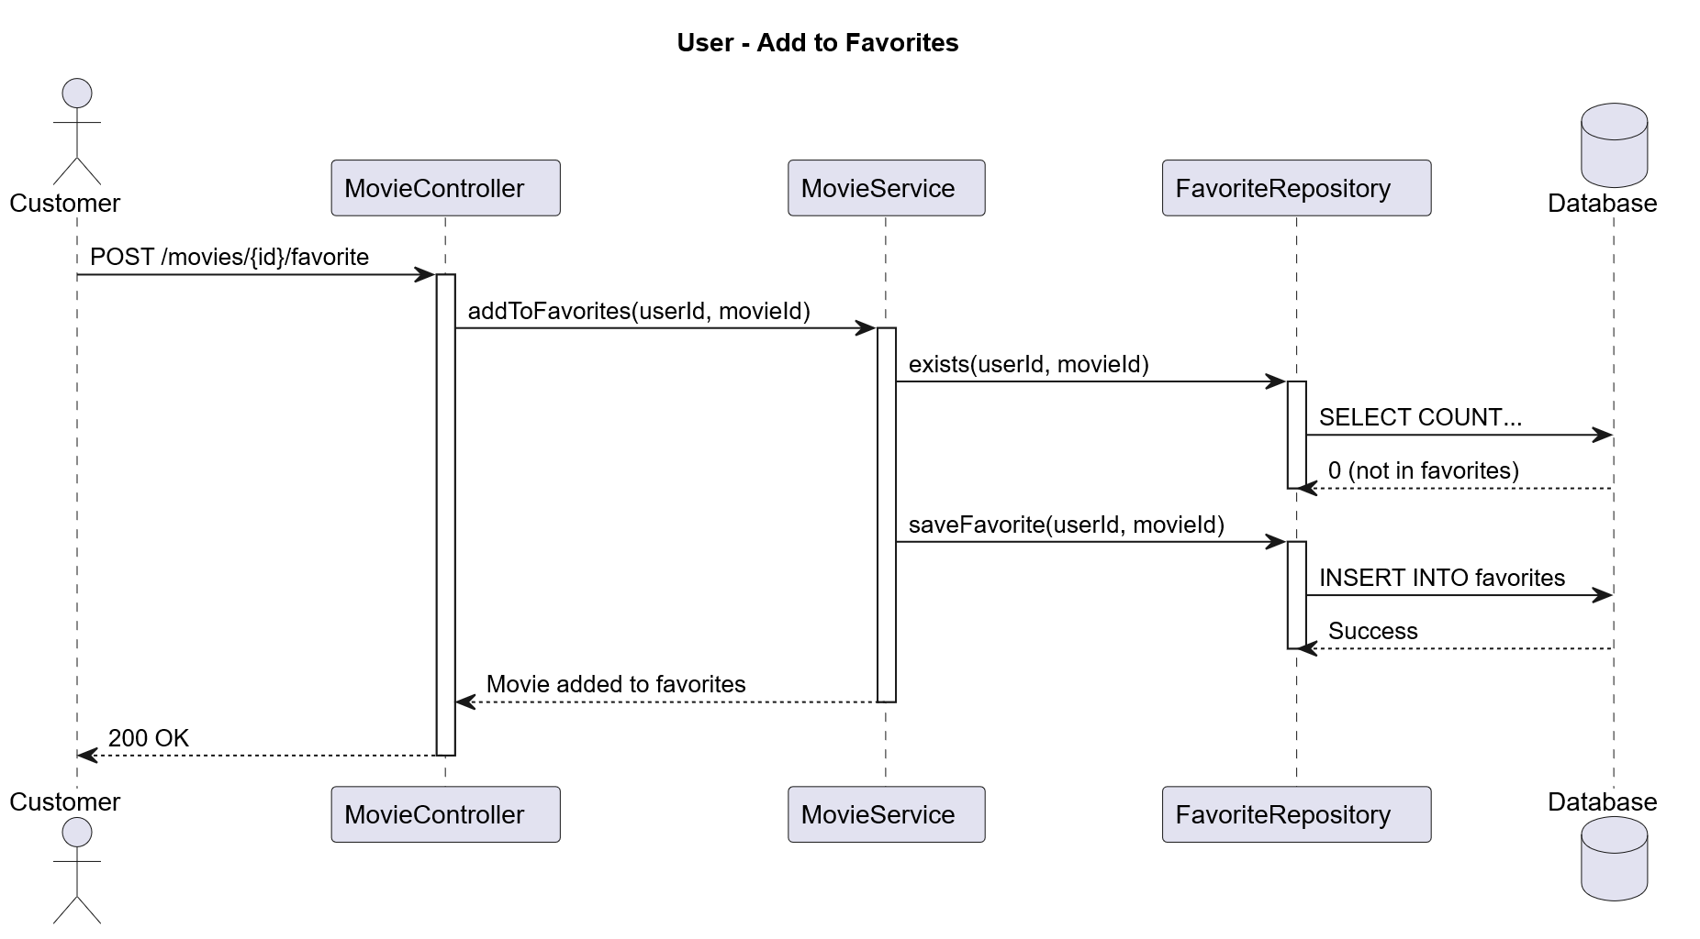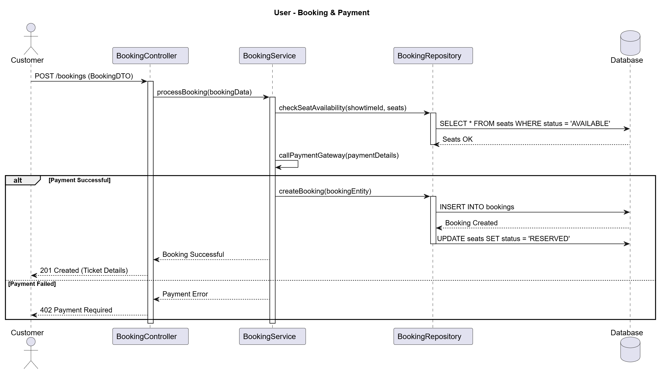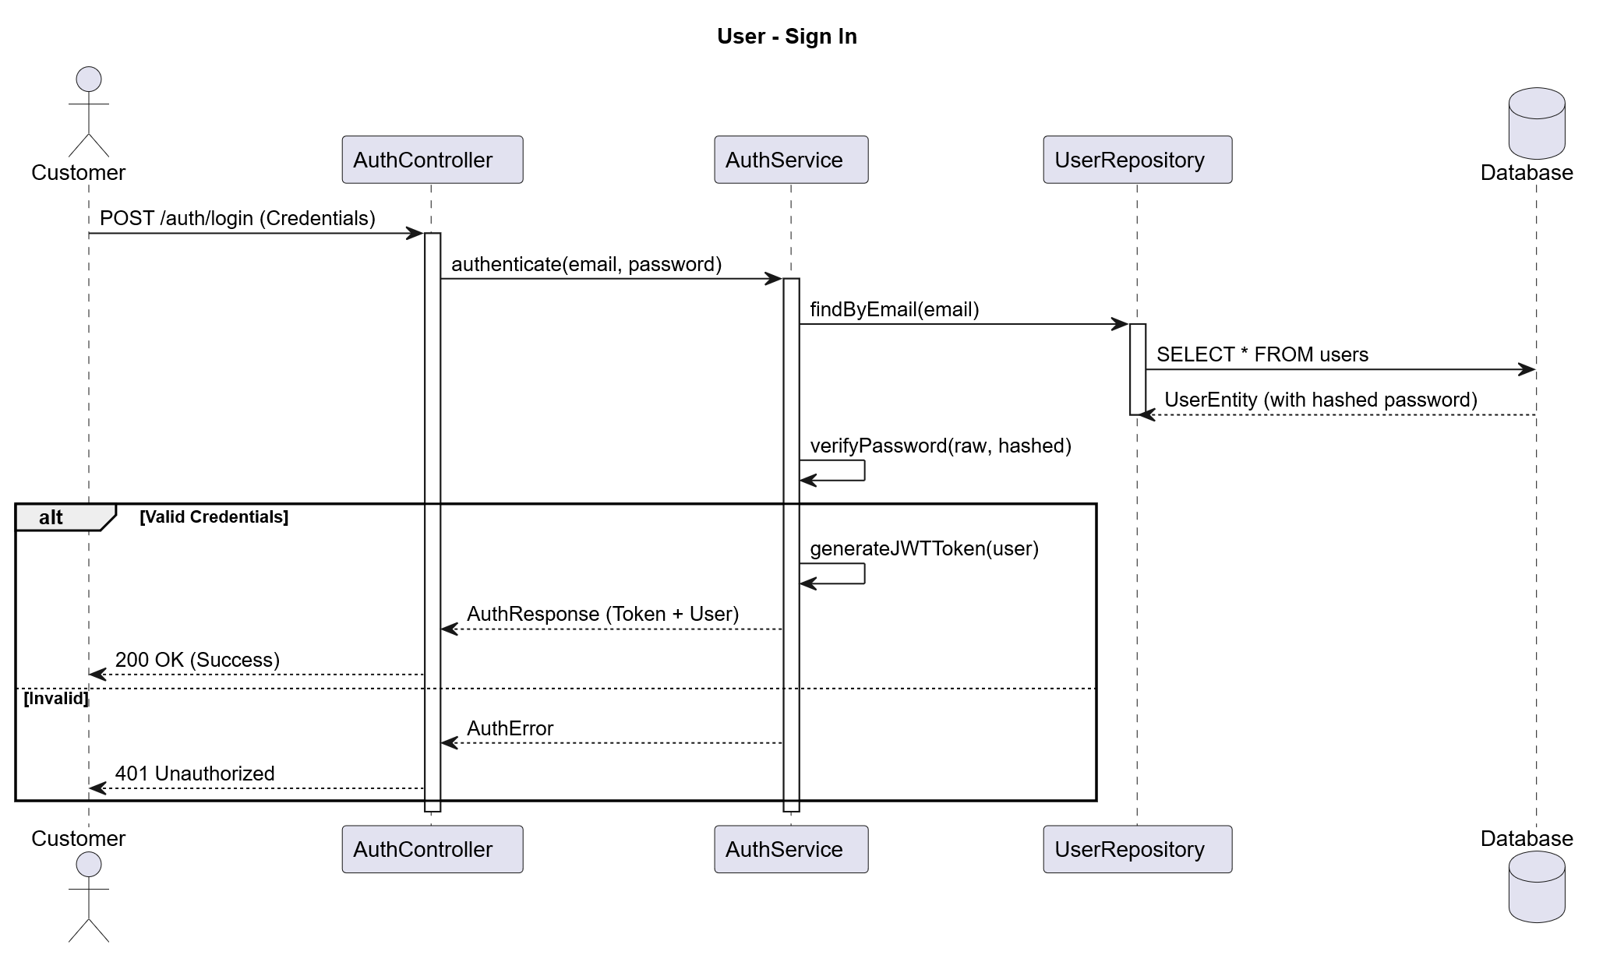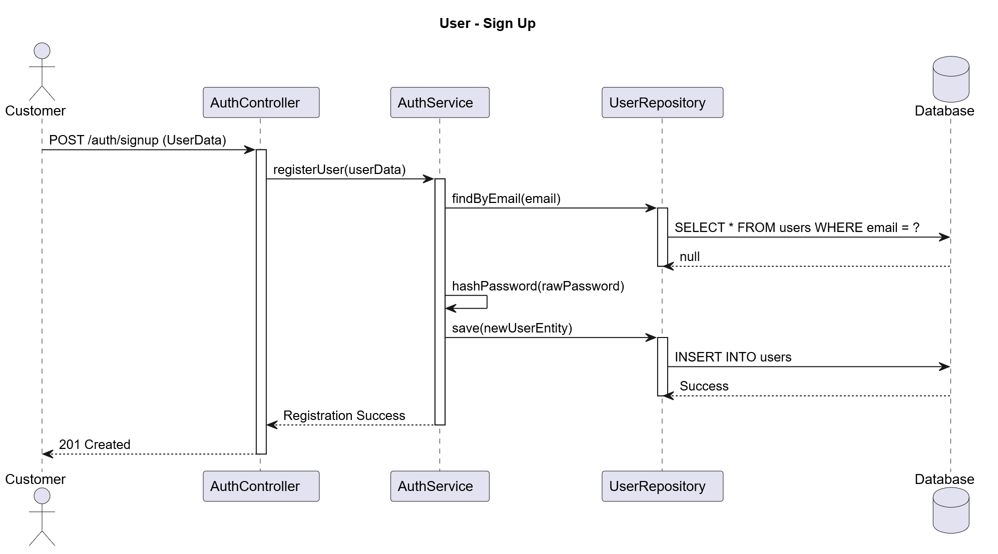

10. ERD Diagram
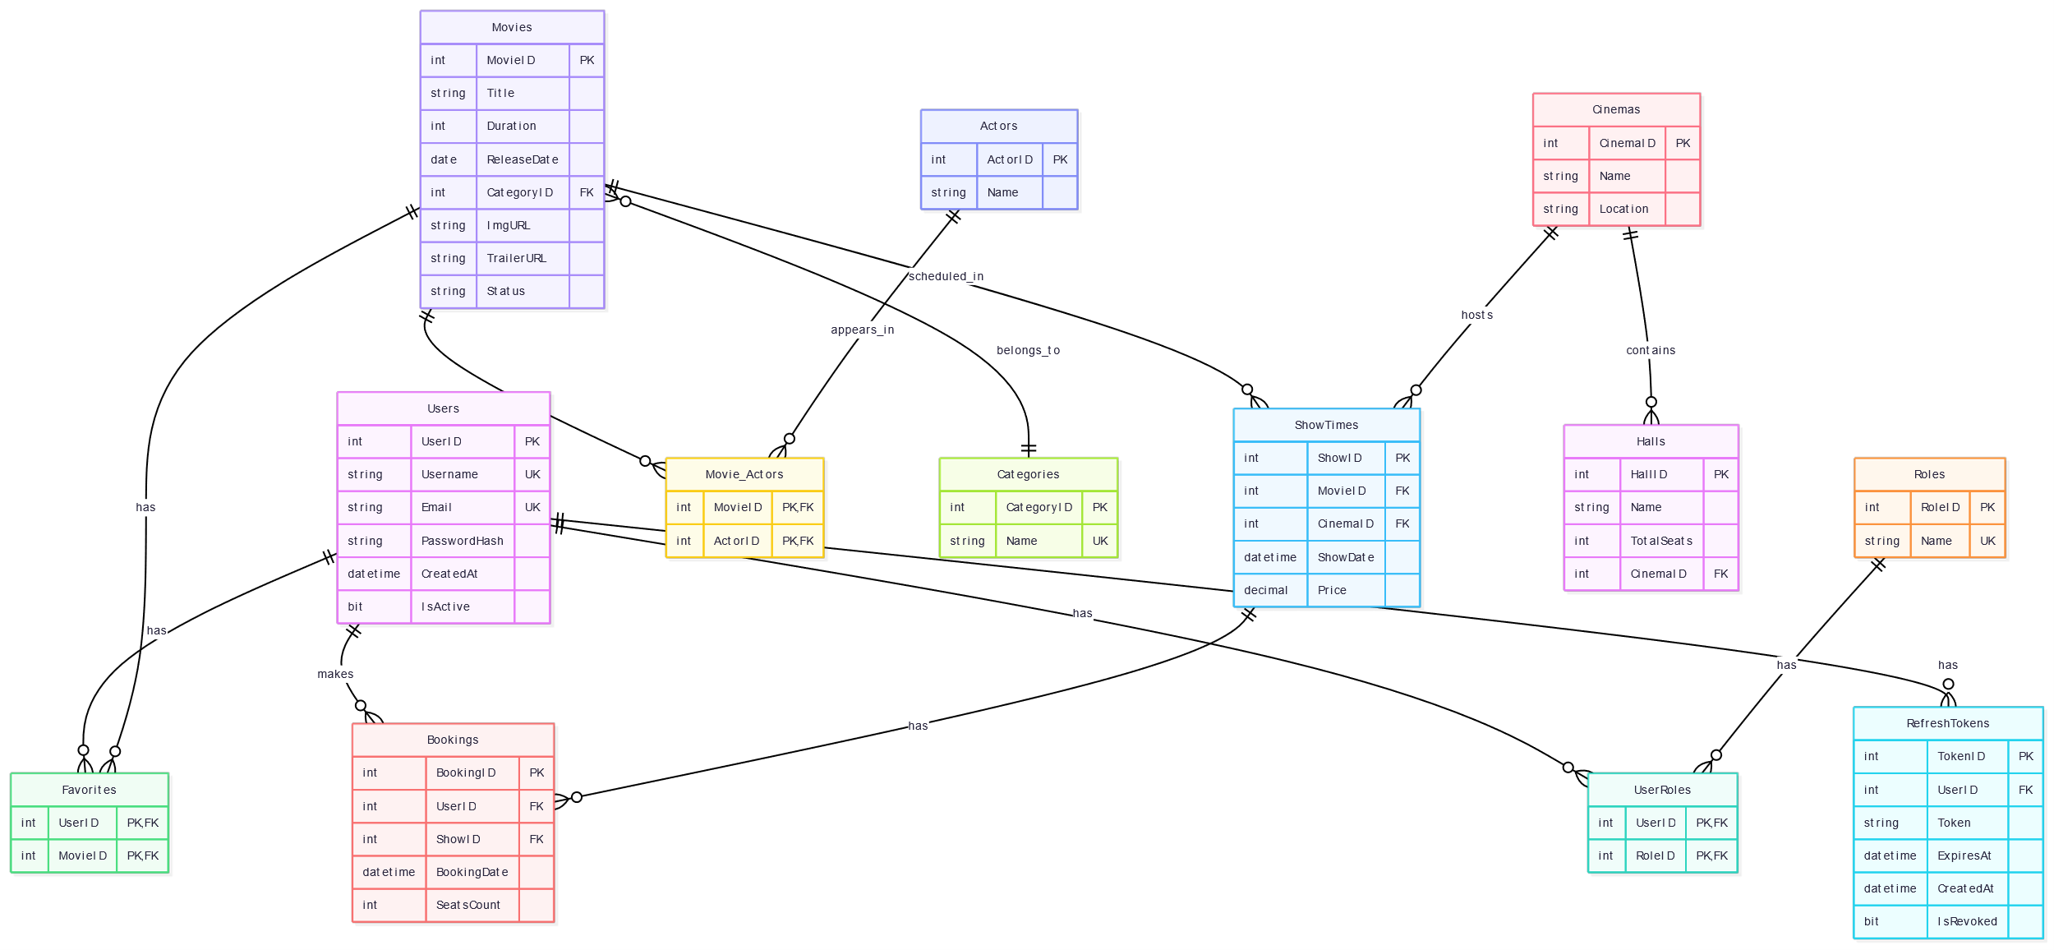

11. OCL Constraints

Booking Constraints
context Booking
inv SeatsPositive:
self.seats > 0
context Booking
inv ValidMovie:
self.movieId <> null

Payment Constraints
context Payment
inv PositiveAmount:
self.amount > 0
context Payment
inv ValidMethod:
self.paymentMethod = 'VISA' or
self.paymentMethod = 'Cash' or
self.paymentMethod = 'MasterCard'

Showtime Constraints
context ShowTimeEntity
inv FutureShowtime:
self.dateTime > currentDateTime
context ShowTimeEntity
inv PositivePrice:
self.price > 0

Hall Constraints
context Hall
inv PositiveSeats:
self.totalSeats > 0

User Constraints
context User
inv UsernameNotEmpty:
self.username <> ''

12. Conclusion
The EgyCinema System provides a scalable and secure cinema booking platform using modern software engineering practices including microservices architecture, REST APIs, Docker containerization, JWT authentication, AWS cloud storage, and UML-based system design.

